|  |  |  |
| --- | --- | --- |
| SQ Project Scopes  * Sport * Health * Activity * Team * Confidence * Body fit * Joy * Socializing * Communications * Road to big sports * Habit * Discipline | |  | | --- | | SPORT SQuAReIlja Magdenko | Daniyar KARIMULLINOV |  Project proposalH\V bars • outdoor equipment • benches • street sports 28/10/2017  Greetings to all!  When people spend their time on the sport ground, it is an efficient way to lead a healthy lifestyle and reduce or give up habits that cause harm on human body. Also, sport grounds can develop speed, strength, endurance and agility that will help to extend life duration and keep the body fit. Moreover, for new-come students or tourists or unconfident people sport ground is the best option to find friends, become more confident and socialised, or even rally a team. Besides, when individual taking a part in certain sport on sport grounds, it is an opportunity to join a big sport. Likewise, there will be equipment that can be easily installed and removed, this is innovation to attract people to do some activities. |

|  |
| --- |
| project budgetCity council • sport brands • universities clubs • local stort shops 28/10/2017   1. Council can show care of people performing such events as most of people will have strong immune system, more daily activity work and more adolescents will go into sport. 2. Sport brands such as addidas, nike, everlast and etc can invest into sport events and this will bring profits to sport companies as people use sport equipment. 3. Uni societies can compete not only with each other, but with regular people who does sport activities. 4. Local shops can sponsor events and it will bring profits to them. |

|  |
| --- |
| Why sport is great idea?City council • sport brands • universities clubs • healfWhy does a person need to move? 1. The most important reason for doing sports is the need to strengthen health, strengthen the heart, and control blood pressure. Exercises performed regularly, promote the resolution of potentially dangerous blood clots in the blood, slow the aging process.  2. When you actively exercise, oxygen gets literally in every cell of the body, so the skin condition improves, and sometimes pimples also disappear. Blood circulation is activated, reflexes are improved. With regular sessions, the work of capillaries (small vessels) improves, on the condition of which the most important functions of the organs of the body depend.  3. Sports exercises tonify muscles, make them strong and hardy. They become more elastic, and you are smart, attractive, sexy and flexible. Your joints acquire a large amplitude of movements. Exercise helps to achieve the ideal weight and maintain it, which can not be achieved only by diet.  4. Thanks to sports exercises, you can control your appetite, because the amount of endorphins increases. They protect the body from a feeling of hunger until it really does not need "recharging".  5. Sports activities help to withstand chronic fatigue, increasing the supply of vitality, increasing the level of energy of your body. They give an extra supply of oxygen to the brain and make you more energetic throughout the day.  6. Regular exercises contribute to a deeper and more peaceful sleep at night, because they stimulate the production of endorphins, helping to get rid of the nervous tension that has accumulated during the day (people who are inactive often experience devastation at the end of the working day, which is not the case with active people who simply feel the feeling pleasant fatigue). Sports exercises help prevent depressive conditions and insomnia, not only because they relieve nervous tension, but also because they prevent the formation of excess adrenaline and hormones that contribute to stress in the body. |

### Where is the great place?

#### parks • gardens • bitch • School teritorys

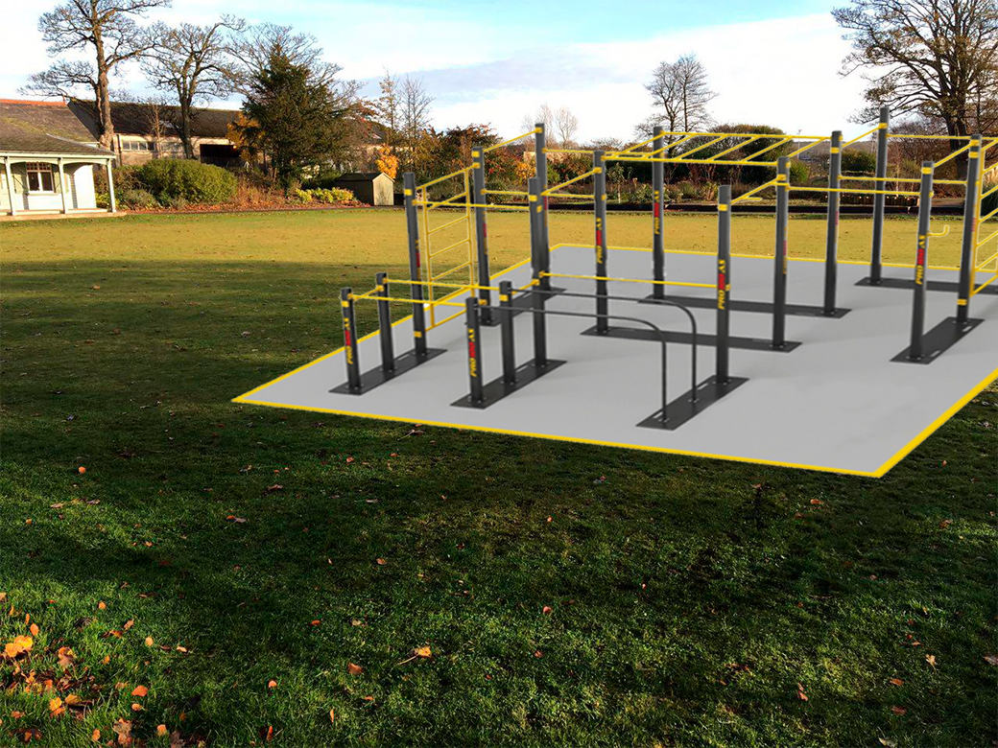

### Where is the great place?

#### parks • gardens • bitch • School teritorys

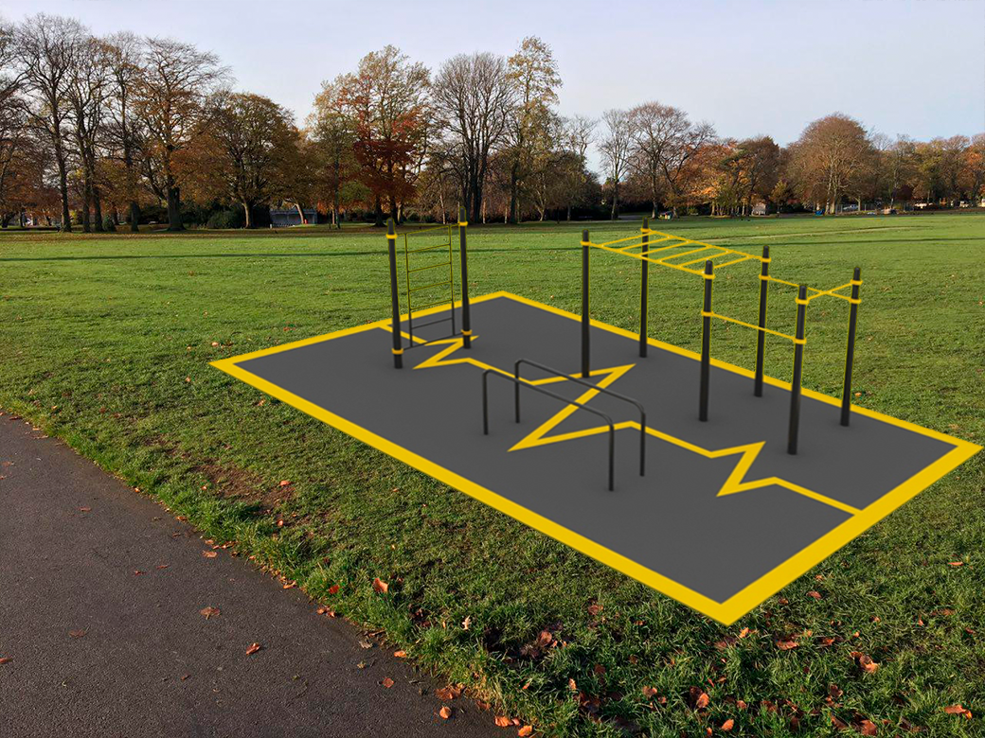

### Where is the great place?

#### parks • gardens • bitch • School teritorys

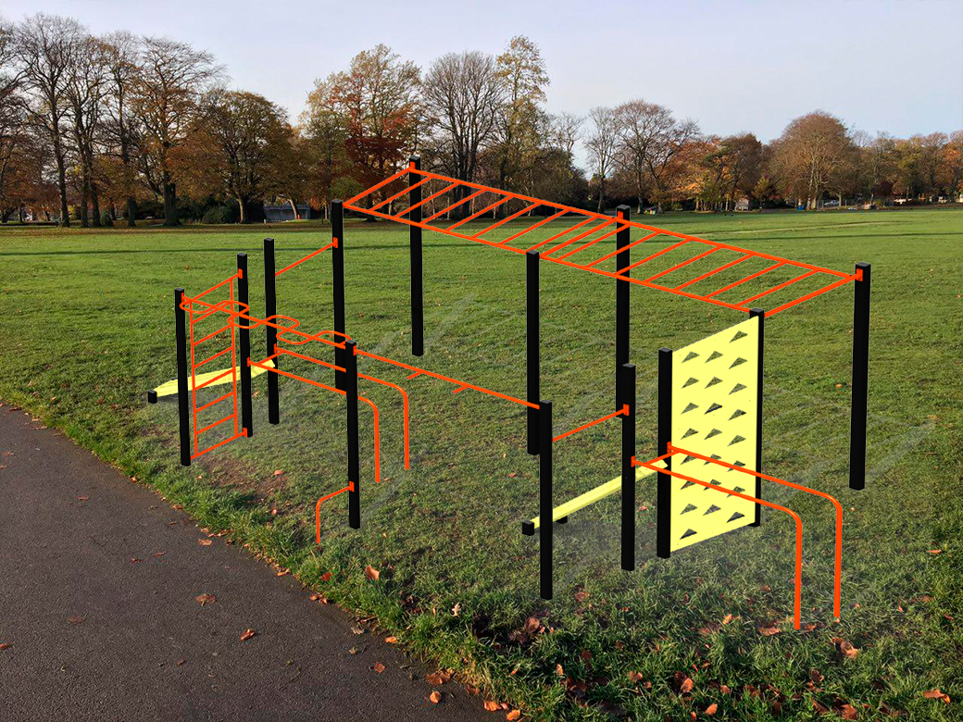

### Some instructions?

#### pullup bars •

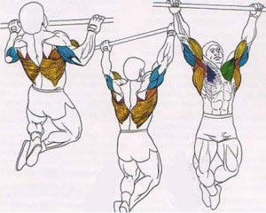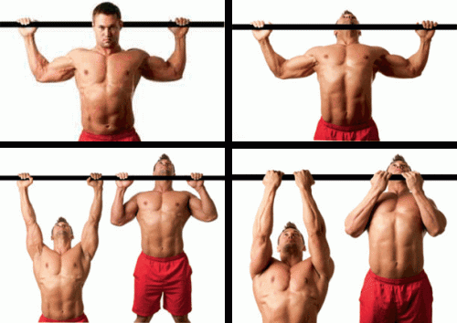

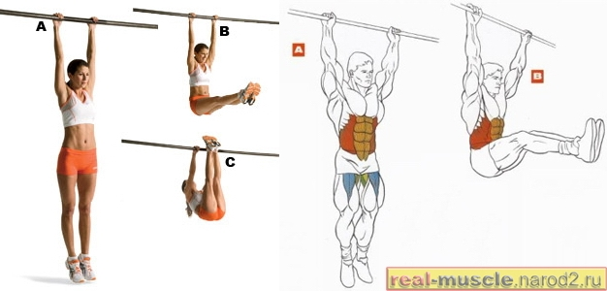

### Some instructions?

#### pullup bars vertical •

